#include<iostream>

#include<cstring>

using namespace std;

class student

{

public:

student(char\*s,int x,int y):id(x),score(y)

{

strcpy(name,s);

}

void input()

{

cout<<"Your Name?";

cin>>name;

cout<<"Your ID?";

cin>>id;

cout<<"Your score?";

cin>>score;

}

void output()

{

cout<<"Name:"<<name<<"ID:"<<id<<"Score:"<<score<<endl;

}

private:

char name[20];

unsigned int id;

double score;

};

int main()

{

student s=student("\0",0,0);

s.input();

s.output();

}#include<iostream>

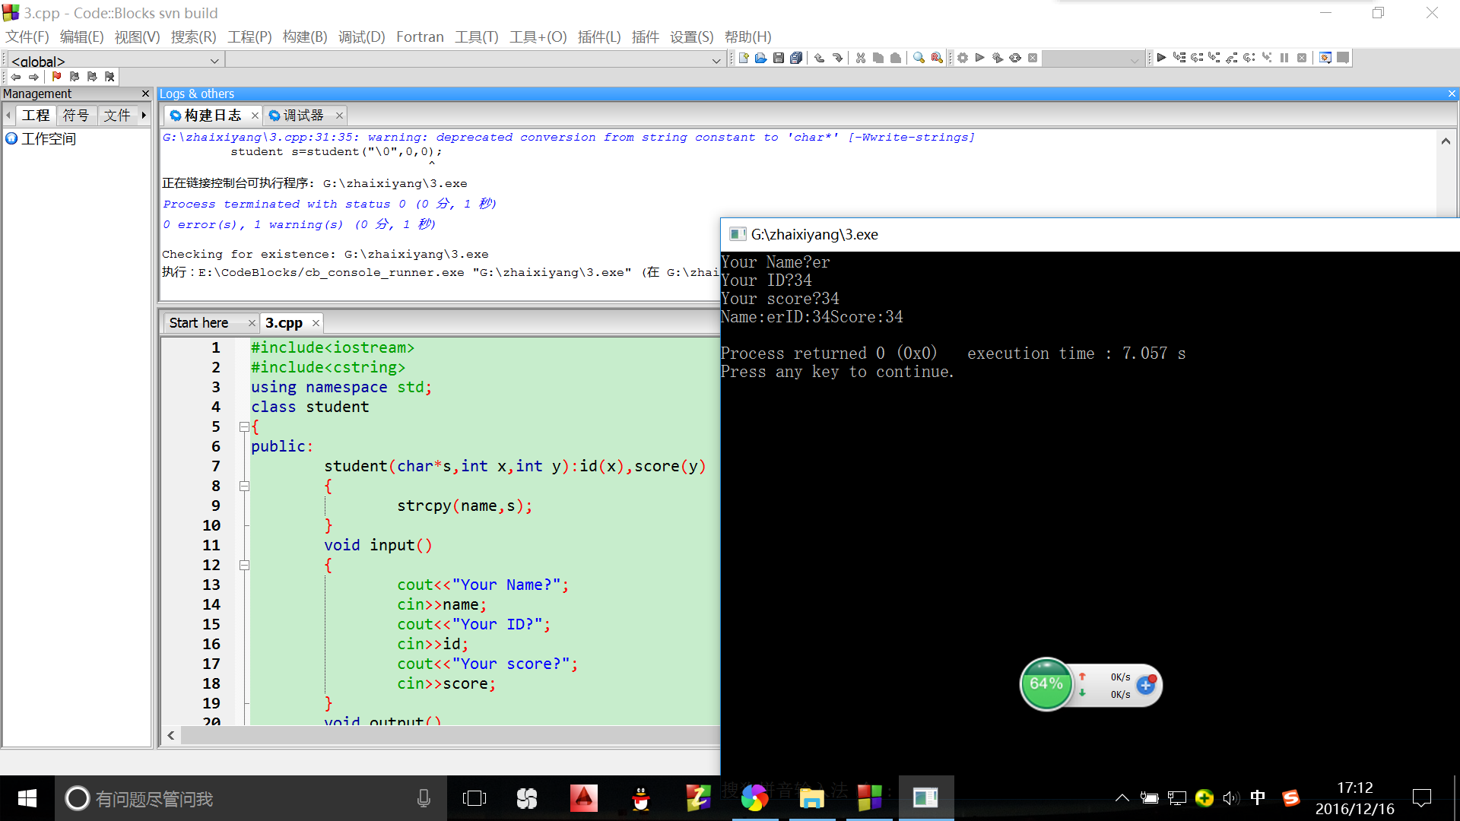

#include<cstring>

using namespace std;

class Book

{

public:

Book(char\*s):price(0),number(0)

{

strcpy(bookname,s);

}

void display()

{

cout<<"Book's Name:"<<bookname<<endl;

cout<<"Price:"<<price<<endl;

cout<<"Number:"<<number<<endl;

cout<<endl;

}

void borrow()

{

if(number){--number,cout<<"You borowed it"<<endl;

cout<<"Now number"<<number<<endl;}

else cout<<"No book for you to borrow"<<endl;

cout<<endl;

}

void restore()

{

cout<<"Book Back"<<endl;

++number,cout<<"Now number"<<number<<endl;

cout<<endl;

}

private:

char bookname[100];

int price,number;

};

int main()

{

Book book=Book("Book");

book.display();

book.borrow();

for(int i=0;i<5;i++)

book.restore();

book.display();

book.borrow();

book.display();

}#include<iostream>

#include<cstring>

using namespace std;

class student

{

public:

void totalscore(double s)

{

score=s;

student::total+=s;

count++;

}

static double sum()

{

return total;

}

static double average()

{

return total/count;

}

private:

double score;

static double total;

static int count;

};

double student::total=0;

int student::count=0;

int main()

{

int n;student s[100];

cout<<"Input number";

cin>>n;

for(int i=0;i<n;i++)

{

double temp;

cout<<"input "<<i+1<<"student's score";

cin>>temp;

s[i].totalscore(temp);

}

cout<<"total score"<<student::sum()<<endl<<"average"<<student::average()<<endl;

}

